Curriculum Vitae
Date prepared: 15/6/2012

Personal Information:
- Name: محمد عمر احمد جاد
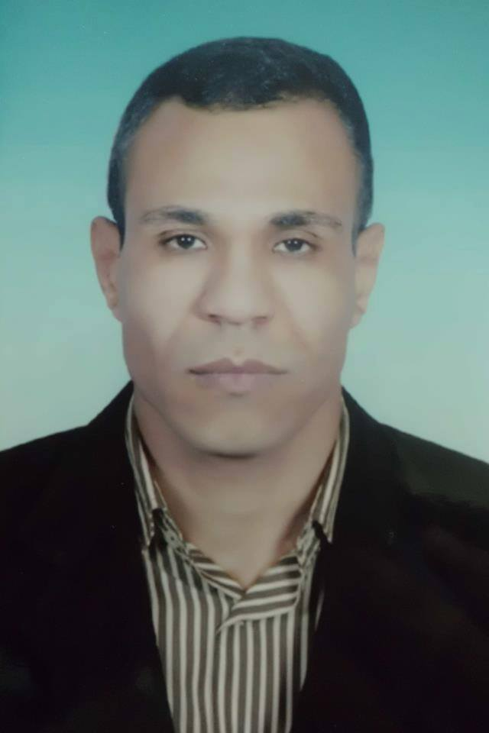
- Gender: ذكر
- Last degree: ماجستير الانف و الاذن والحنجرة
- Date and place of birth: 7 نوفمبر 1981 قفط قنا مصر
- Citizenship:مصري
- Current home address: El-Adly Street, Assiut, Egypt
- Work address: Department of Otorhinolaryngology, Faculty of Medicine, Assiut University, 71526 Assiut, Egypt
- Phones:
- Home: 002-088- 2292999
- Cellular: 00201227006258
- Work: 002-088-2413559
- E-mail: Mohamedomar18@yahoo.com
- Marital Status: Married
- Non-medical interests: Football
- Languages spoken:
- Arabic (native).
- English (fluent).
- French: 2-years study in the high school.

Education:

9/1998-9/2004: Student, Faculty of Medicine, Assiut Univ., Assiut, Egypt
3/2005-3/2006: House-officer, Assiut Univ. Hospital, Assiut, Egypt
Graduation: Bachelor’s Degree in Medicine and Surgery: Faculty of Medicine, Assiut Univ., Assiut, Egypt, September, 2004 Excellent with Honor. [1]
3/2006-3/2009: Resident, Otorhinolaryngology Dept., Assiut Univ. Hospital, Assiut, Egypt
Master of Science (M.Sc.) [Otorhinolaryngology]: Faculty of Medicine, Assiut Univ. Hospital, Assiut, Egypt, April, 2009; Excellent. [2]

Professional Licensure:

Egyptian ministry of health full registration, 4/3/2006 (3)

Faculty Academic Appointments:

5/3/2009-27/8/2009: Demonstrator, Otorhinolaryngology Dept., Assiut Univ. Hospital, Assiut, Egypt.
27/8/2009-present: Assistant lecturer, Otorhinolaryngology Dept., Assiut Univ. Hospital, Assiut, Egypt.
Other Professional Positions:

High board member of "Continuous Improvement and Qualifying for Accreditation Project" in the Faculty of Medicine, Assiut University.

Professional Societies:

2009: Member of the Egyptian Oto-rhino-laryngological Society (www.orlegypt.org). [4]

Community Service:

2009: Member of "Together we make life" Society, medical sector; a local social society concerned with helping poor people and social development.

Research Activities:

2006-2009: "Recent trends in management of recurrent sinonasal inverted papilloma ", (review article): Ragaii Ali , El shafaii Hamza. (my M.Sc essay).

Conferences attended:

15-17/ 12/ 2010: The 4th Assiut International Conference of Otolaryngology, Luxor, Egypt.
10-12/10/2012: The 1st Annual conference of Integrated Medicine (IMC, 2012), Assiut, Egypt.
Teaching Activities:

- Supervising house officers since March,2006.
- Supervising the work of residents since March, 2009.
- Involved in undergraduate student teaching since March, 2009.
Computer Sciences:-
International Computer Driving License (ICDL Certificate), 2008
Clinical Experience:(5)

During my work as a house officer, as a resident and as an assistant lecturer, I gained experience in the following activities:
- Out-patient clinical management,
- In-patient clinical management,
- Management of traumatized patients,
- Emergency surgery: in the emergency unit of my department concerned with the reception of cases like emergency airway management, control of bleeding after tonsillectomy or adenoidectomy, control of epistaxis by anterior or post-nasal packing , drainage of nasal septal haematoma or abscess and closed reduction of recent nasal bone fractures and in addition, in the trauma unit in my university hospital.
- Elective surgery, including:
- Basic functional endoscopic sinus surgery
- Trans-septal approach to the sphenoid sinus.
- Reduction of the size of inferior nasal turbinate (by different methods)
- Submucous resection of the nasal septum.
- Rigid hypopharygoscopy and oesophagoscopy
- Direct rigid laryngoscopy
- Elective tracheostomy
- Uvulopalatopharyngoplasty
- Myringotomy (with or without ventilation tube application)
- Tonsillectomy
- Adenoidectomy
- Myringoplasty
- Cortical mastoidectomy
- Tympanoplasty (assisted)
- Submandibular sialadenectomy
- Sistrunk operation
- Assistance in the following operations:
- Transnasal endoscopic approach to the sphenoid sinus.
- Dacryocystorhinostomy(DCR) under sinuscopic guidance
- Septorhinoplasty
- Maxillectomy(partial and total)
- Tempromandibular joint ankylosis
- Cleft palate repair
- Superficial parotidectomy under facial nerve monitoring
- Radical and modified radical mastoidectomy
- Stapes surgery
- Acoustic neuroma removal through translabyrinthine approach
- Glomus tumor surgery
- Temporal bone resection in middle ear carcinoma
- Tympanic neurectomy
- Facial nerve exploration
- Ossicular reconstruction
- Total laryngectomy
- Thyroidectomy
- Total hypopharyngolaryngectomy and reconstruction with pectoralis major flap
- Tracheal resection and anastomosis
- Nasopharyngeal angiofibroma resection
- Resection of inverted papilloma
- Bronchoscopy
- LASER arytenoidectomy and posterior cordectomy
- Endoscopic excision of laryngeal polyps and nodules

Referees and References:

[1] Assiut University was inaugurated in 1957 to encourage research, education and community services in Upper Egypt. It is located in Assiut City which is 375 Km south of Cairo, the capital. The university comprises sixteen faculties and two higher institutions. PO Code No. 71515, Egypt. http://www.aun.edu.eg
[2] Assiut University Hospital is one of the biggest University Hospitals in Egypt. It is the core referral center for the whole Upper Egypt that serves about twenty million people. The hospital contains 2027 beds, including 94 ICU beds, and 46 operative theaters in which 240 operations are performed daily. 1478 medical and 6428 paramedical staff serve in this hospital. 3000 patients visit the outpatient clinics and 1000 are received in the emergency departments daily. The department of Otorhinolaryngology contains 40 beds. http://www.aun.edu.eg/fac_med/medicin/Hospital2.htm
[3] Egyptian Oto-rhino-laryngological Society. http://www.orlegypt.org.
[4] Egyptian Medical Syndicate. http://www.ems.org.
[5] Mohammed Mohamed kamal el deen; professor,head of Otolaryngology Dept., Assiut Univ. Hospital, E-mail: dmmkamal@yahoo.com

Last Updated: 16/6/2015

